[Comparative Study Of Countries](https://public.tableau.com/app/profile/samiksha.borade/viz/ComparitiveStudyOfCountriesProject_16710759608380/Map-IncomeGroup?publish=yes)

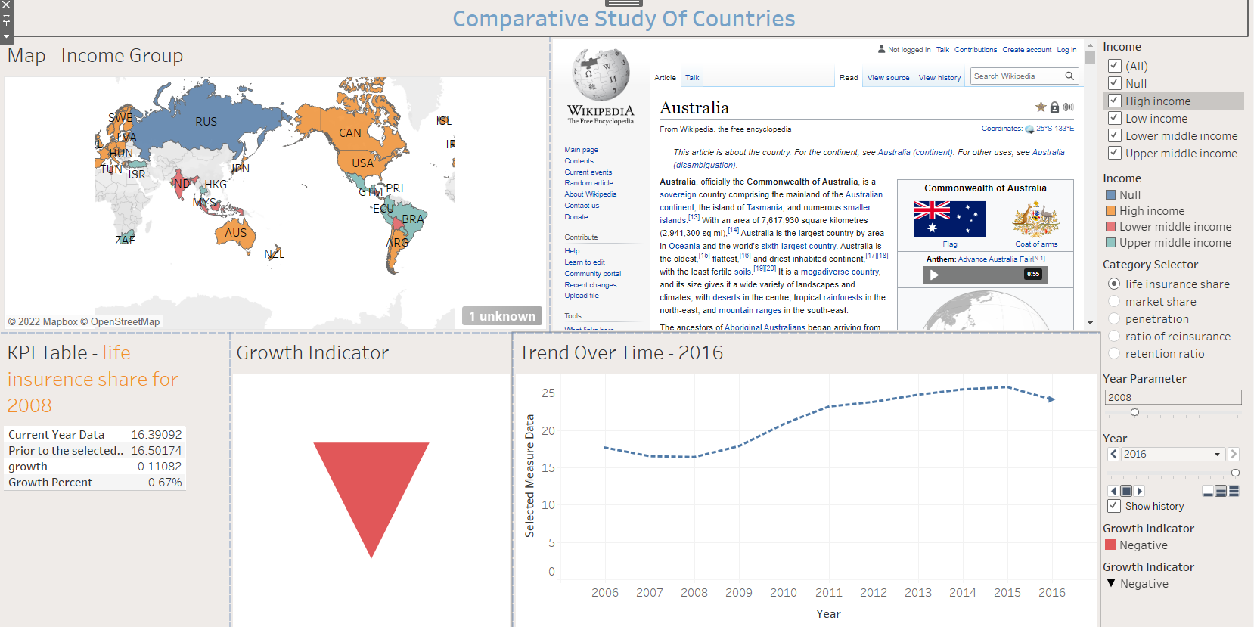

Write Up-

A geographical map showing countries field. Color the map based on Income column from secondary dataset.

Include a filter of income group to the dashboard

Include a webpage to show data from World Bank webpage driven by an URL action from geography graph